Documentation: Bizhunt Pro Wordperss Theme
Install Bizhunt Pro Wordpress Theme.
Bizhunt Pro is a WordPress theme. It is a simple, clean, responsive and user-friendly theme. This theme is designed for special business company. It can helps to upgrade your business as well.

Pro Features
- Theme colors
- Contact page
- FAQs page
- Portfolio page
- Pricing page
- Services page
- Team page
- Testimonial page
- Design of sidebar left or right

How to Start?
Here are some following questions and answers for startup this theme setup. It helps you to complete the basic configuration of Bizhunt Pro.

How to set up a static front page in WordPress?

How to upload, install and active the Bizhunt Pro?

What is page and how to create it?

What is category and how to create?

How to create menus?

How and where to place Widget of your website?

How to create posts?

How to add logo and set the site title?

How to add google map and contents in contact page?

How to set up a static front page in WordPress?
- Firstly create a page.
- Select the Template as FrontPage shown in right side.
- And that publish it.
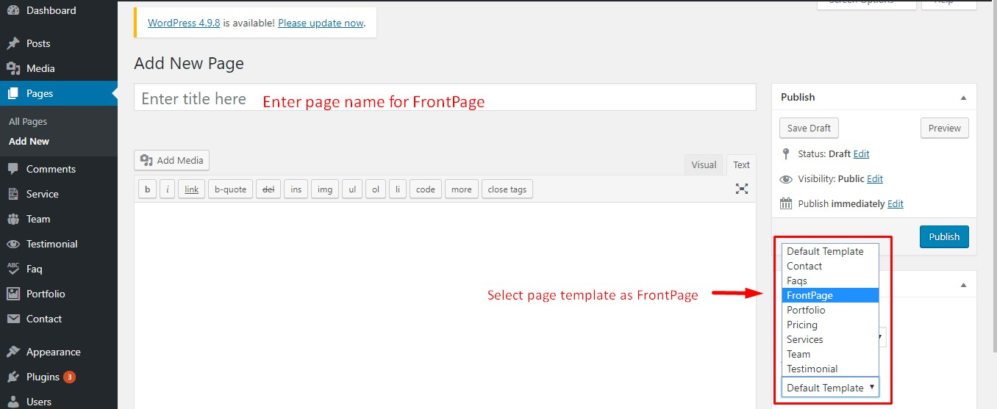

- Go to Setting -> Reading in the dashboard of your WordPress.
- Select the FrontPage as given name in above process.
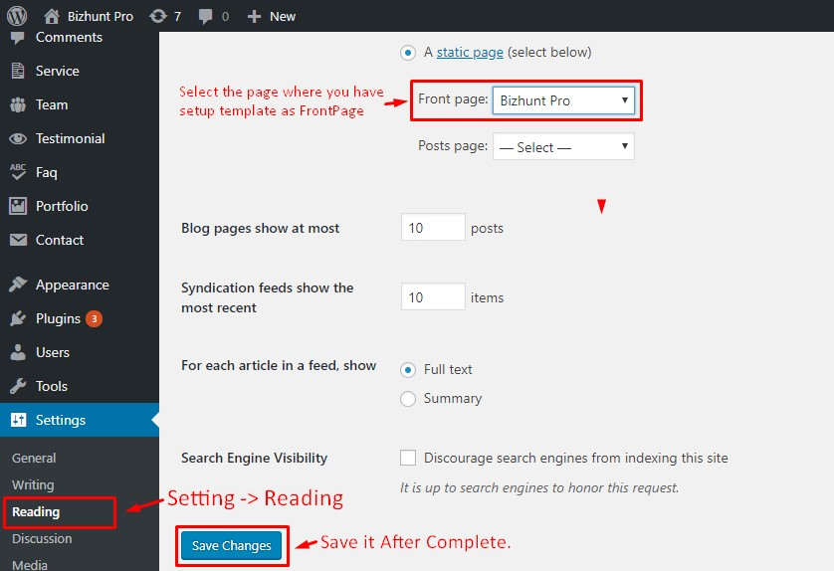

How to upload, install and active the Bizhunt Pro?
From your Dashboard of WordPress
- Login as admin panel
- Go to Appearance >> Themes
- Click in Add New >> Upload Bizhunt-pro.zip
- Install Now >> Active The Theme
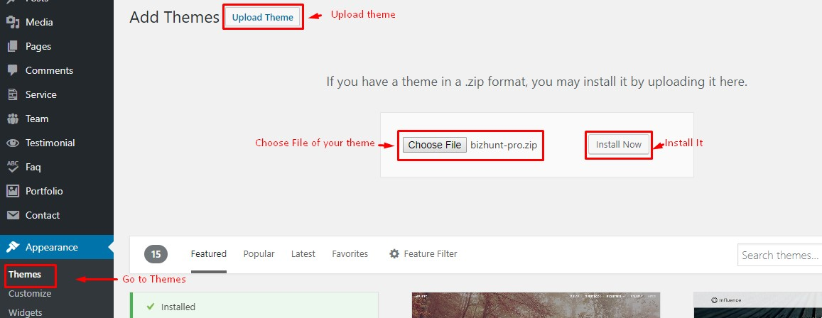

What is page and how to create it?
Pages are the static. It does not have the categories and tags.
- Go to the Dashboard
- Click in Pages >> Add New
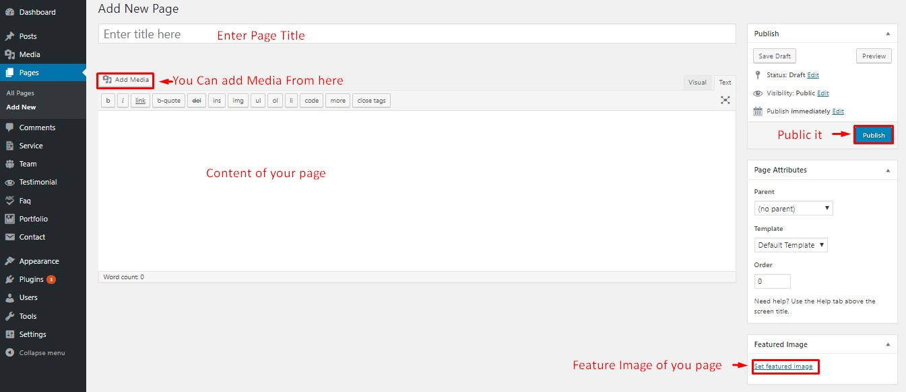

What is category and how to create?
Categories are the one which is used to sort and group the content into different sections. Tis categories is used to divide the content on variety of topics.
- Go to the Dashboard
- Click in Posts >> Categories
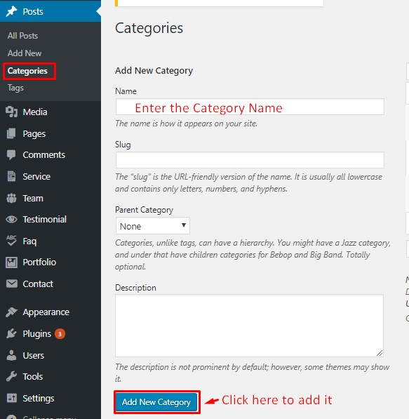

How to create menus?
Here we need two menu. Primary Menu and Footer Menu.
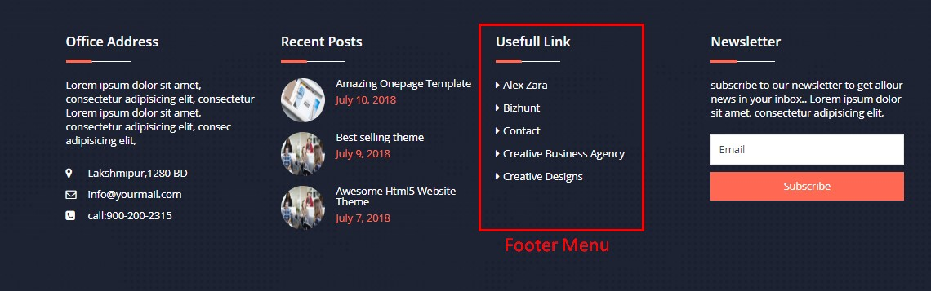
To create Menu
- Go to the Dashboard
- Click in Appearance >> Menus
- Give name of the menu
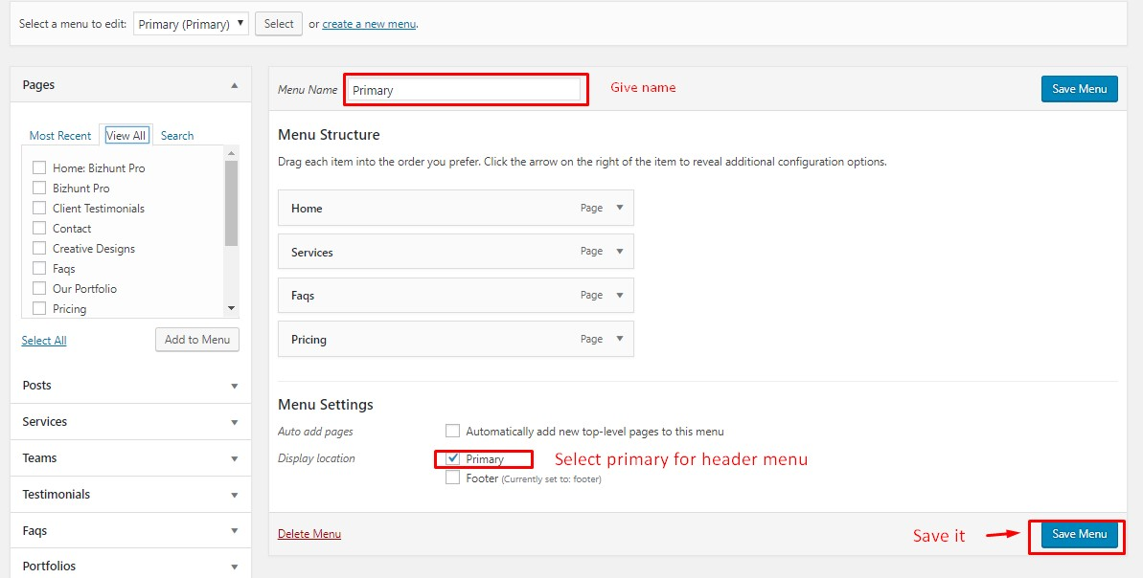

How and where to place Widget of your website?
It is important to know where to place widgets in sidebars.
- Go to the Dashboard
- Click in Appearance >> Widgets
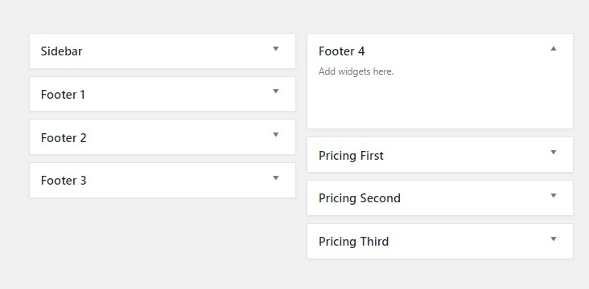
Available Widgets of Bizhunt Pro, you can just drag and drop to sidebar.
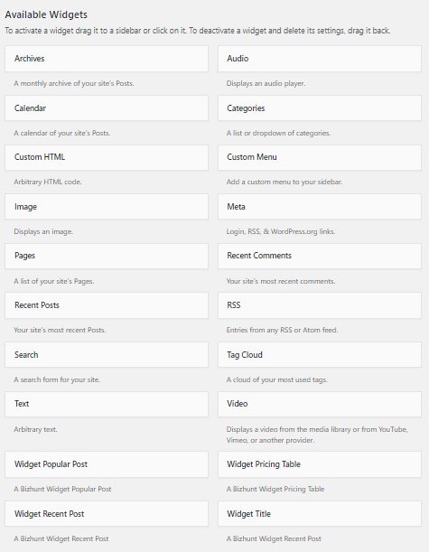

How to create posts?
- Go to the Dashboard
- Click in Posts >> Add New
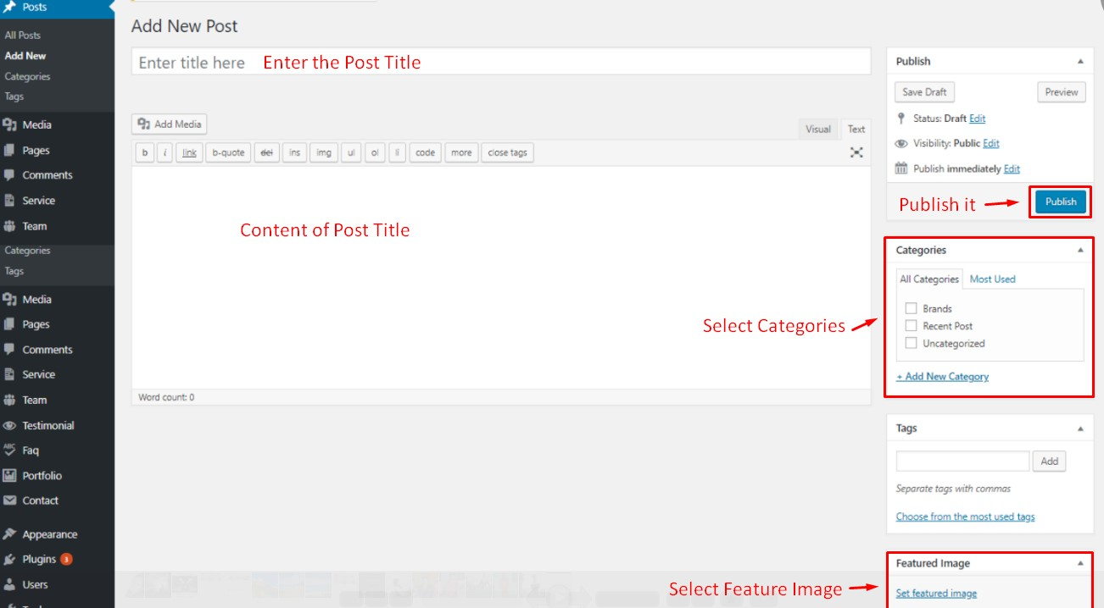

How to add logo and set the site title?
- Go to the Dashboard
- Click in Appearance >> Customize
- Click in Site Identity
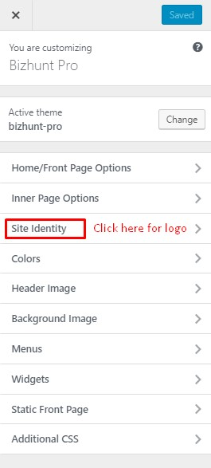
- Add Logo Image
- Add site Title
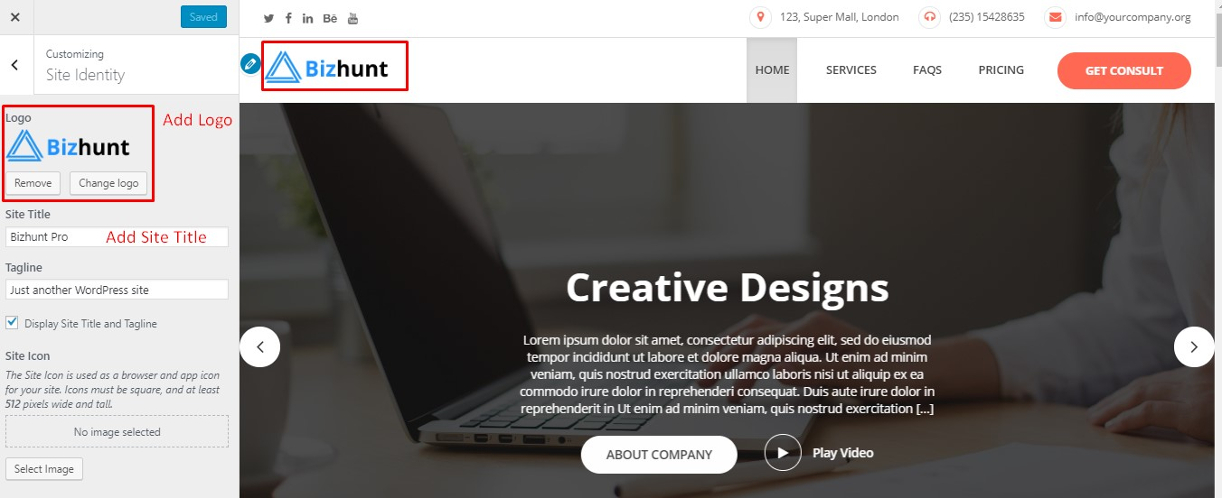

How to add google map and contents in contact page?
- Go to the Dashboard
- Click in Appearance >> Customize
- Click in Inner Page Options
- Click in Contact Page Section
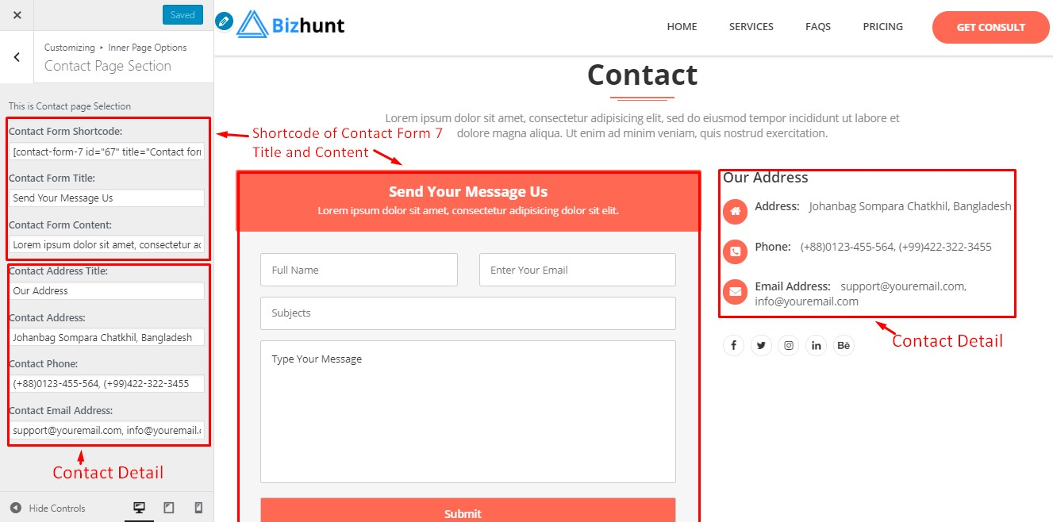

Want to show sidebar in left side or right side?
- Go to the Dashboard
- Click in Appearance >> Customize
- Click in Inner Page Options
- Click in Sidebar Section
